A Mini-Project Report on

**FLY BIRD GAME**

Submitted in III Semester

**Bachelor of Engineering**

In

**Computer Science and Engineering**



Submitted by

##### SATHVIK TN 1DS17CS101

**SHRAVANAKUMAR BAJANTRI 1DS17CS106**

**RAGHAVENDRA 1DS17CS083**

**SAGAR 1DS17CS096**

##### Under the guidance of

##### PROF.**POORNIMA A B**

##### Designation,

##### Dept. of CSE, DSCE

2018-2019

**Department of Computer Science and Engineering,**

**DAYANANDA SAGAR COLLEGE OF ENGINEERING**

**BANGALORE – 560078**

**FLY BIRD**

**SYNOPSIS:**

The project mainly deals with breadth-first traversing(BFS) the nodes of a tree. This is used to searching of a tree or graph data structures .

BFS is a traversing algorithm where you should start traversing from a selected node (source or starting node) and traverse the tree layer-wise, thus exploring the neighbour nodes (nodes which are directly connected to source node). We move towards the next-level neighbour nodes.

Breadth first search (BFS) is an algorithm for traversing or searching tree or graph data structures. It starts at the tree root (or some arbitrary node of a graph, sometimes referred to as a 'search key'), and explores all of the neighbor nodes at the present depth prior to moving on to the nodes at the next depth level**.**

**TABLE OF CONTENTS**

1 Introduction

2 Design and Implementation

3 Result

4 Conclusion & Analysis

5 References

##### 

**INTRODUCTION:**

Breadth-first search (BFS) is a method for exploring a tree or graph. In a BFS, you first explore all the nodes one step away, then all the nodes two steps away, etc. Breadth-first search is like throwing a stone in the center of a pond. The nodes you explore "ripple out" from the starting point.

Here's a how a BFS would traverse this tree, starting with the root:

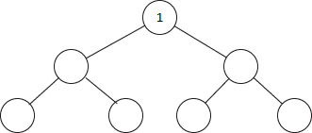

We’d visit all the immediate children (all the nodes that are one step away from our starting node):

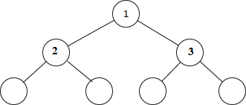

Then we’d move on to all those nodes’children (all the nodes that are two steps away from our starting node):

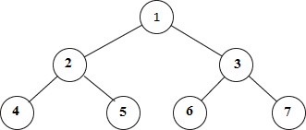

And so on until we reach the end.Breadth-first search is often compared with depth-first search.

**IMPLEMENTATION:**

The traversing will start from the source node(root) and push(enqueue) root to queue.

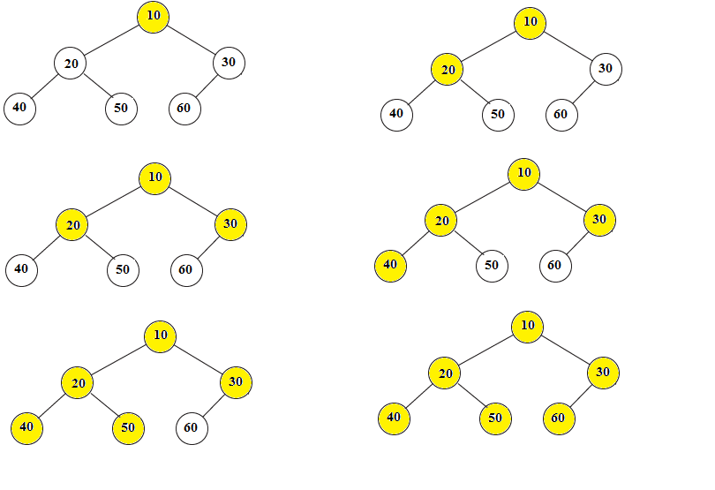

.

According to the fig.,implementation is explained here.

Step 1:

* Root 10 will be popped from the queue and printed.
* Children of root i.e. 20 and 30 will be traversed and enqueued to queue.
* 10 is marked as ‘visited’.

Step 2:

* 20 is popped from the queue.
* Children of 20 i.e. 40 and 50 are traversed and enqueued to queue.
* 20 is marked as ‘visited’.

Step 3:

* 30 is popped from the queue.
* Children of 30 i.e. 60 is traversed.
* 30 is marked as ‘visited’.

Step 4:

* 40 is popped from the queue.
* Since there are no children,there will me no enqueue.
* 40 is marked as ‘visited’.

Step 5:

* 50 will be popped from the queue.
* Since there are no children,there will me no enqueue.
* 50 is marked as 'visited'

Step 6:

* 60 is popped from the queue
* Since there are no children,there will me no enqueue.
* 60 is marked as 'visited'

The queue is empty and it comes out of the loop. All the nodes have been traversed by using BFS.

**RESULT:**

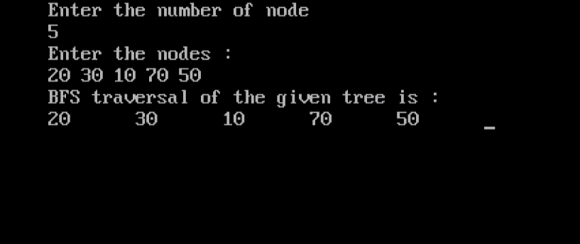

**ANALYSIS/CONCLUSIONS:**

This project deals with BFS where you should start traversing from a selected node (source or starting node) and traverse the tree layer-wise thus exploring the neighbour nodes (nodes which are directly connected to source node). We move towards the next-level neighbour node.

**REFERENCES:**

1 www.hackerearth.com

2 www.interviewcake.com

3 www.wikipedia.org